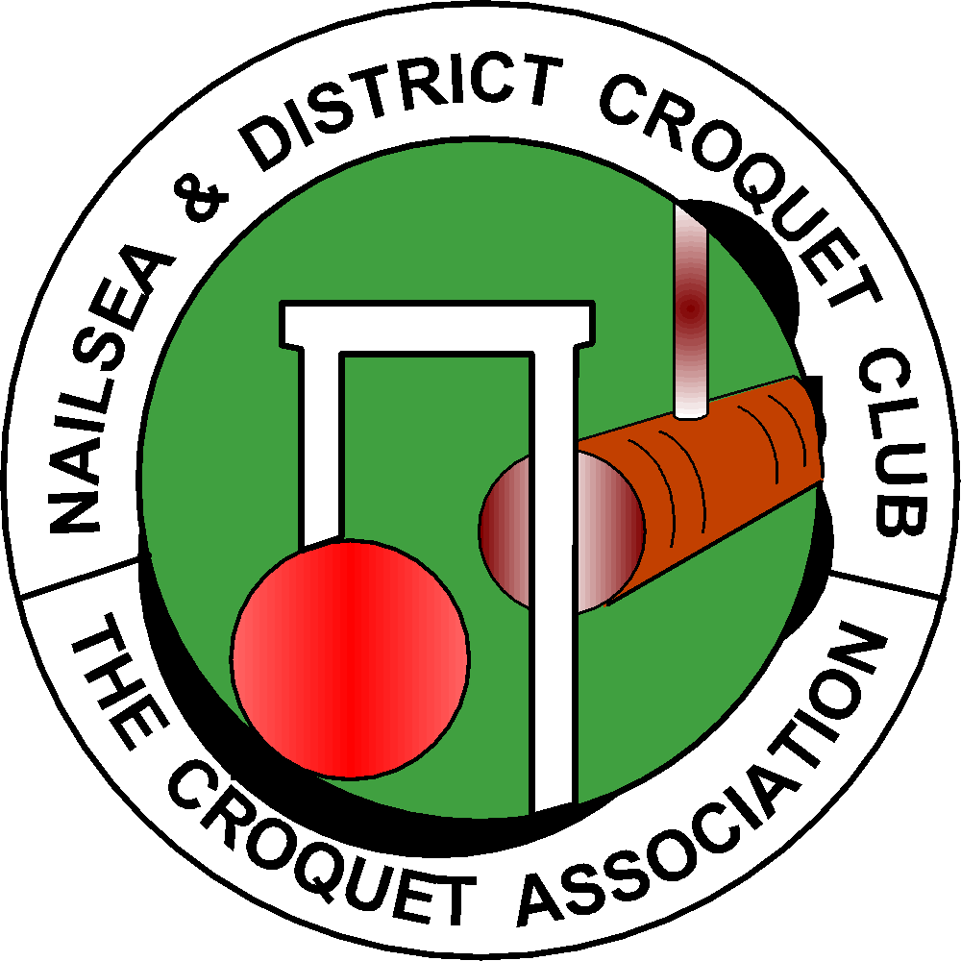

NAILSEA & DISTRICT CROQUET CLUB

APPLICATION for MEMBERSHIP RENEWAL 2020 - 2021 Season

Please EITHER email the completed form to: ajwimshurst@gmail.com and make a bank transfer for your subscription to the club’s bank account, Sort Code 40-14-12, Account Number 51286013, including your name in the Reference field, OR post the completed form to Andrew Wimshurst, Dring Cottage, Lower Langford, BS40 5BW with a cheque payable to Nailsea and District Croquet Club.

First name: | Surname:
Address:

Post code:
Home Telephone: |  | Mobile:
Email:
May we give this information to other members? ...Yes or... No
Croquet Association Member …….Premium or ….Standard
Class of membership applied for: ( Please Circle)  Full Membership………………………………………………………………..£150  Associate membership - those with a primary membership of another club…. £105*  Country membership - players living at least 25 miles from the club…………..£75  Junior membership - players in full time education and below the age of 25…...£50  Social membership - non playing members who wish to join the clubs social activities………………………………………………………………………….£15  * Please provide details of your primary club. |  |  | Full  Associate  Country  Junior  Social
Do you hold a key to the club house? - Yes……..No
Do you wish to have a club house key? Yes or No. If you do please include a deposit of £10 together with the cost of the membership you are applying for.

In line with the new CA guidelines all members were entered on the CA database in 2019. Everyone is a Standard Member of the CA unless you have indicated that you hold Premium status. Your name, contact details and email address are visible as per your instructions. Please confirm your choice by signing page 2. This is required each year for the club to comply with data protection.

Further clarification, Standard membership of the Croquet Association provides the following benefits:

- You receive every edition of the Croquet Gazette by email and access to all past issues via the CA website. If you do not use email you may receive your Gazette by mail, but you have to pay the associated costs. Please ask the membership secretary if this is of interest to you.

- You can access contact details of any CA member who has given permission for other CA members to see them.
- You are entitled to enter as many CA listed tournaments as you wish.
- You are entitled to discount at the CA shop.
- You can vote on a number of issues, including who should represent the South West Federation on the CA council.
- Membership administration by the club’s membership secretary is simplified.
- The CA’s position is strengthened when seeking sponsorship, exposure in the media, etc.

The CA’s privacy policy undertakes to reveal your personal information to nobody without your explicit permission. Unless you specify otherwise, it will only be used to send you the Croquet Gazette and information which it is believed you should have. In practice it will be unusual to receive anything other than the Croquet Gazette.

Please confirm one of the following options.

I do not wish any CA members to be able to see my personal record □

I give consent for my personal record to be visible to CA members who
are members of Nailsea & District Croquet Club □

I give consent for my personal record to be visible to all CA members □

NAME (Print) :
............................................................................................................................

Signature:

Date:

