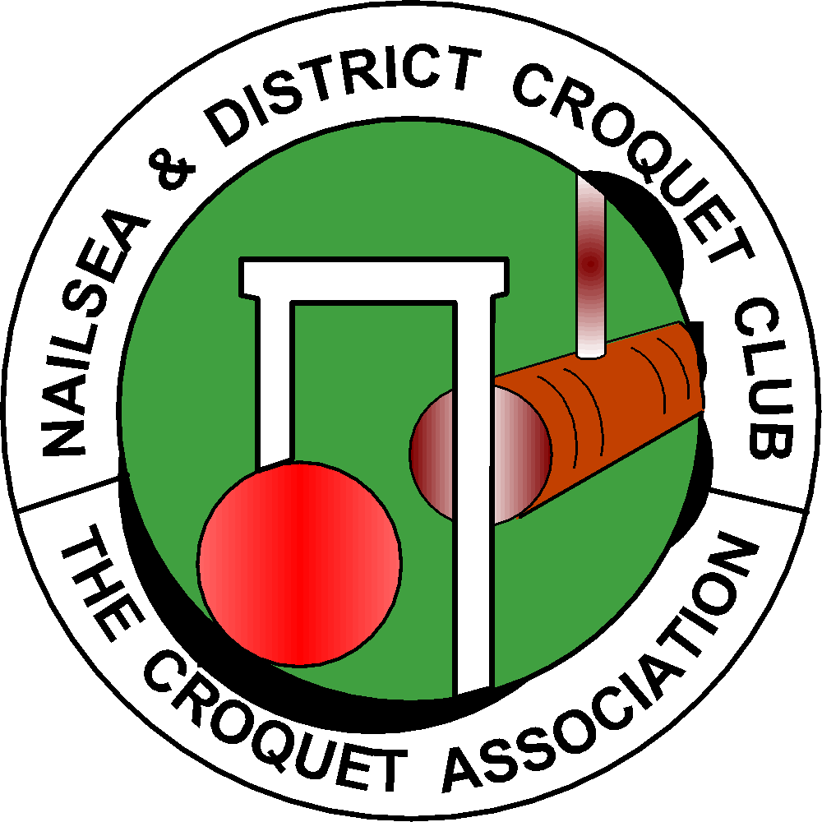

NAILSEA & DISTRICT CROQUET CLUB

APPLICATION for MEMBERSHIP or MEMBERSHIP RENEWAL for the 2024 Season

Please EITHER email the completed form to: ajwimshurst@gmail.com and make a bank transfer for your subscription to the club’s bank account, Sort Code 40-14-12, Account Number 51286013, including your name in the Reference field, OR post the completed form to Andrew Wimshurst, Dring Cottage, Lower Langford, BS40 5BW with a cheque payable to Nailsea and District Croquet Club.

First Name: | Surname:
Address:

Post Code:
Landline: |  | Mobile:
Telephone number in case of an emergency:
Email address:
May we give this information to other members:
May we use any photo in which you appear in publicity:
Are you a Premium Croquet Association Member Yes / No
Annual Subscription due 1st Jan 2024 are set out below. Please Circle or highlight in bold which membership category & payment amount.
Please note we offer a discount if paid before 31st Dec 2023.

MEMBERSHIP  CATEGORY | 2024 ANNUAL SUBSCRIPTION  DUE 1st JAN 2024 | 2024 ANNUAL SUBSCRIPTION  IF PAID BY 31st DEC 2023
FULL | £200 | £180
(U25) | £60 | £54
ASSOCIATE | £140 | £126
COUNTRY | £100 | £90
SOCIAL | £20 | £18

Full membership - anyone over 25 on the 1st Jan.
U25 membership - players 25 or under on Jan 1st.
Associate Membership - those with a primary membership of another club.*
Country Membership - those living at least 25 miles from the club.
Social Membership - members wishing to join in the club's social activities only.

(* Please provide details of your primary club.)
Do you hold a key to the club house? Yes or No
If you wish to have a key please pay £10.00 by BACS - Sort Code 40-14-12
Account No: 51286013 or cheque payable to Nailsea and District Croquet Club.
In line with the CqE guidelines all members will be entered on the CqE database . Everyone is a Standard Member of the CqE unless you have indicated that you hold Premium status. Your name, contact details and email address are visible as per your instructions. Please confirm your choice by
signing page 2. This is required each year for the club to comply with data protection.

Standard Membership of the Croquet England (CqE) provides the following benefits:

- Entry to domestic tournaments listed in the CqE Calendar.
- Eligibility for CqE selection events and events representing the CqE internationally.
- Receive paper copies of the CqE Magazine: The Croquet Gazette (for new members until end of calendar year of joining, or of following calendar year if joining on or after 1st August).
- HoldCqE coaching and refereeing qualifications.
- Subsidy for training as a Club Coach or Referee.
- Access to the CqE Awards Scheme.
- 2% Member Discount from CA Shop.
- Vote in CA elections and on motions before general meetings.

The CqE’s privacy policy undertakes to reveal your personal information to nobody without your explicit permission. Unless you specify otherwise, it will only be used to send you the Croquet Gazette and information which it is believed you should have. In practice it will be unusual to receive anything other than the Croquet Gazette.

If this application is being made on behalf of someone aged 17 or younger on the 30th September last, only enter contact details that you are happy to have circulated to NDCC members.
Otherwise enter your own contact details and we will contact your child in this way.

Please confirm one of the following options. ( Tick or highlight )
I do not wish any CqE members to be able to see my personal record. □
I give consent for my personal record to be visible to CqE members who
are members of Nailsea & District Croquet Club. □
I give consent for my personal record to be visible to all CqE members. □

NAME (Print): .................................................................................................................

Signature: ………………………………….Date:.........................

D.O.B. - optional

Please circle any of the following that you feel you could help with: Mowing, White Lining,
Hoop Setting, Irrigation, General Maintenance or Clubhouse Cleaning.

